To ensure safe and efficient transportation, all fields must be filled in and submitted to the RRDTS Consortium as soon as possible. If there are any changes, parents need to immediately contact their child’s school with revised information.
Student’s Given Name:
Parent/Guardian’s Name:
Home Address:
Home Phone: |  |  | School to be Attended: |  | Grade:

PICK-UP AND DROP-OFF INFORMATION:
If you require both primary address & alternative address transportation please fill out TWO forms.

Days for which transportation will be needed: M T W T F
Student Will Depart From; Primary Address: Alternative Address: Courtesy Request: (Check one)
Street Address |  | Fire #
Town/Township
Caregiver/Daycare
Name/Telephone #

Days for which transportation will be needed: M T W T F
Student Will Return To; Primary Address: Alternative Address: Courtesy Request: (Check one)
Street Address |  | Fire #
Town/Township
Caregiver/Daycare
Name/Telephone #

Effective Date: |  |  | (must be filled in)
Signature of Parent/Guardian: (required) |  |  |  | Date:
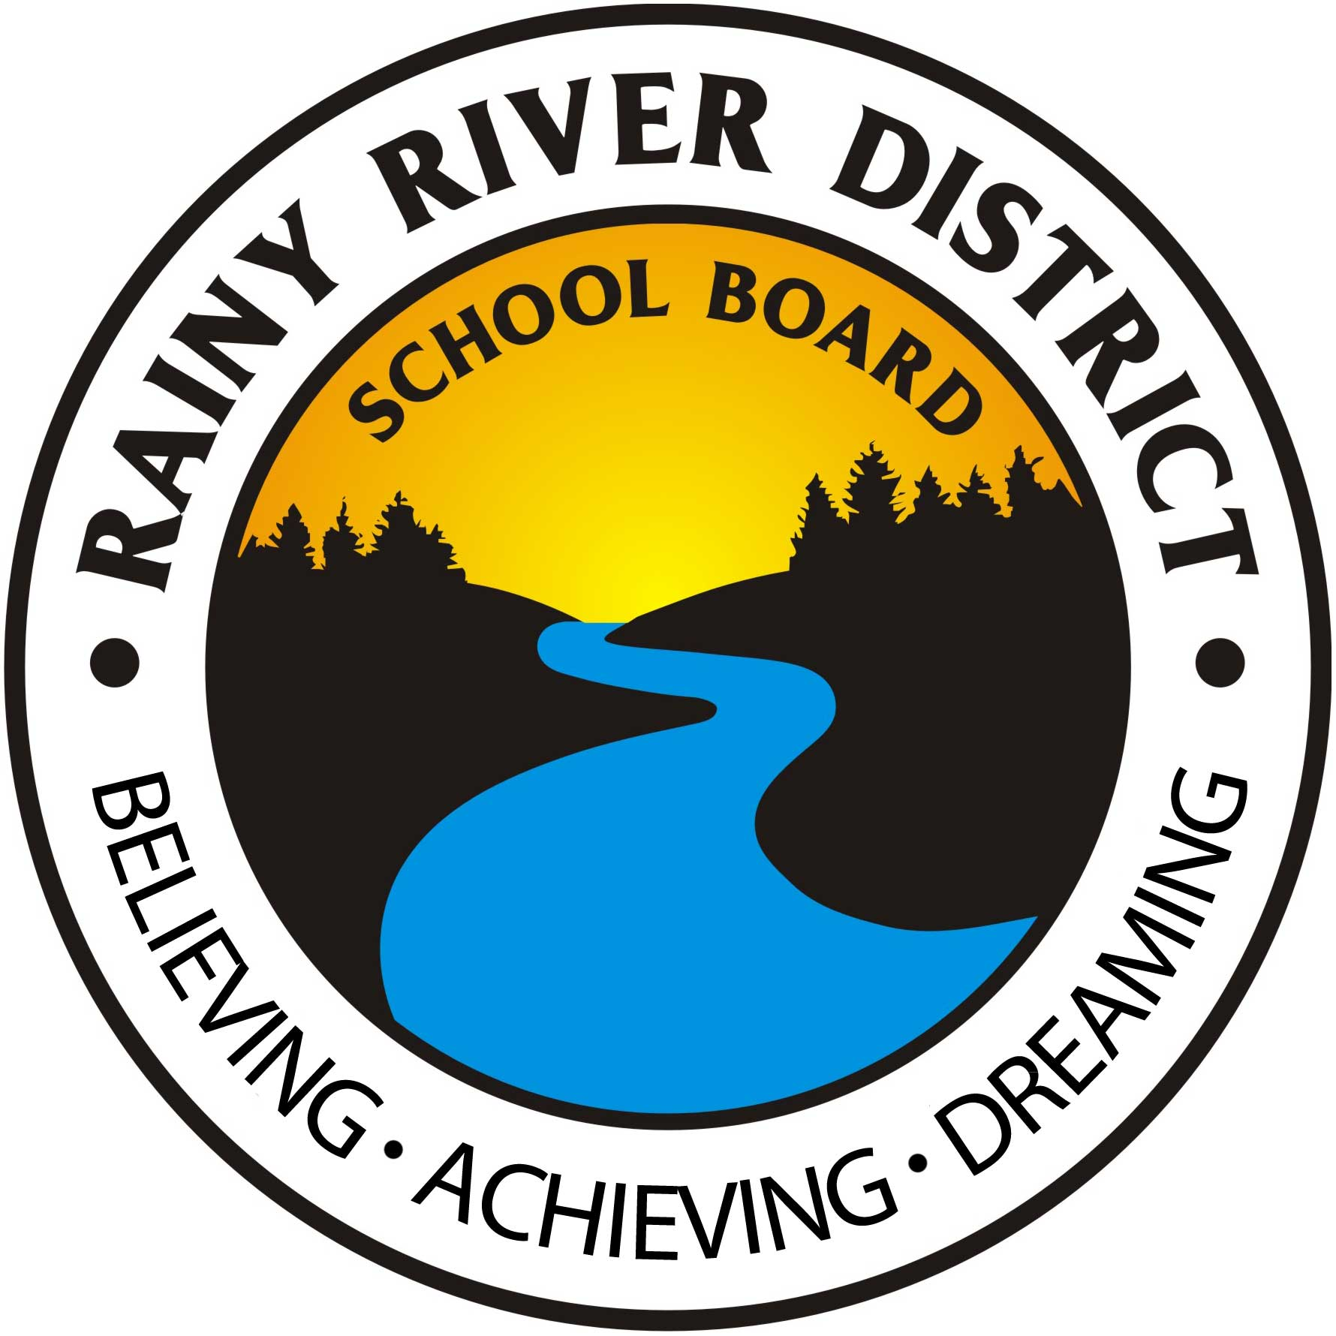 Return completed form to the school or via fax 807-275-4975 or email rrdtsc@rrdsb.com
All student transportation details will be faxed to the school by the RRDTS Consortium within 3 business days of receipt of this form.

Rainy River District Transportation Services Office use Only:
Date Received: _________________ Approved Denied Date Effective: ________________________

